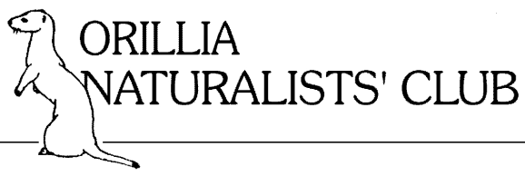

MEMBERSHIP FORM 2021-2022
Last Name Click here to enter text. First Name Click here to enter text.
Last Name Partner Click here to enter text. First Name Partner Click here to enter text.
Address Click here to enter text.
P.O. Box Click here to enter text. R.R. # Click here to enter text.
City Click here to enter text. Prov. Click here to enter text.
Postal Code Click here to enter text. Telephone Click here to enter text.
E-mail Click here to enter text.
New ☐ Renewal ☐
Family $ 30 Individual $ 20
---------- Under 30 Free ----------
If you wish to make a donation to the "Orillia Naturalists’ Club" to support its projects, a receipt for Income Tax purposes will be issued. The ONC is an incorporated, federally registered charity.

Donation $Click here to enter text.
Enclosed: Cheque $Click here to enter text. Cash $ Click here to enter text.
Please send this completed form with your cheque payable to the Orillia Naturalists’ Club to:
Orillia Naturalists’ Club
c/o Treasurer
P.O. Box 2381
Orillia, ON L3V 6V7
PLEASE CLEARLY FILL IN ALL SECTIONS APPLICABLE and SEND BEFORE END OF NOVEMBER

