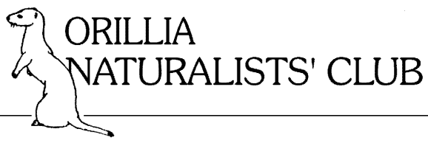 | MEMBERSHIP FORM 2024-2025

Please complete this form and print clearly

Last Name: ___________________________ First Name: _______________________________
Partner Last Name: ______________________ Partner First Name: _______________________
Address: ________________________________________________ P.O. Box: ______________
R.R #: _______ City: ______________________ Prov: ______ Postal Code: ________________
Telephone: ______________________ Email: _________________________________________
MEMBERSHIP & DONATION INFORMATION:

Membership Type: Family $30 Individual $20 Under 30 years old - free
Membership Status: New Renewal
Donation: $20 $50 $100 Other: $___________
Total Contribution: $____________
Donations are vital to the Club to cover expenses, support projects, retain knowledgeable speakers and help local conservation efforts. Thank you!

CONTRIBUTION INFORMATION:
  Please send this form with your cheque to: Orillia Naturalists’ Club  c/o Treasurer  P.O. Box 2381. Orillia, ON L3V 6V7 |   Alternatively, please send an e-transfer to orillianaturalists@gmail.com, noting membership type, and any additional donation, in the memo section.

The Orillia Naturalists’ Club is an incorporated, federally registered charity. We will provide a charitable receipt for Income Tax purposes. Charitable Number: 137975777RR0001.
orillianaturalistsclub.ca | Facebook @orillianaturalistsclub | Instagram @OrilliaNature

